**Group Project Assignment**

**Course: INFO2350-25S-Sec4**

**Members: Dhwanit, Manav, Basanta, Neel,**

**Professor: Nicola Cedic**

**Due Date: 8 Aug, 2025**

GitHub Link 3

**Task 1: Architecture Diagram** 3

**Task 2: Implementation : Launch EC2 Web Server (in Public Subnet)** 4

**Part A: VPC and Gateway** 4

**Description** 4

**Preparation** 4

**Observations** 5

**Reflection** 5

**Screenshots:** 5

**Part B: Launch EC2 Web Server (in Public Subnet)** 10

**Description** 10

**Preparation** 10

**Observations** 11

**Reflection** 11

**Screenshots:** 11

**Part C: Launch EC2 DB Server (in Private Subnet)** 14

**Description** 14

**Preparation** 15

**Observations** 15

**Reflection** 15

**Screenshots:** 16

**Task 3: Terraform & automation** 21

**Description** 21

**Preparation** 21

**Observations** 21

**Reflection** 21

**Screenshots:** 22

**Task 4: Security Considerations** 27

**Screenshots:** 29

# **GitHub Link**

<https://github.com/Dhwanit14/aws-cloud-project.git>

# **Task 1: Architecture Diagram**

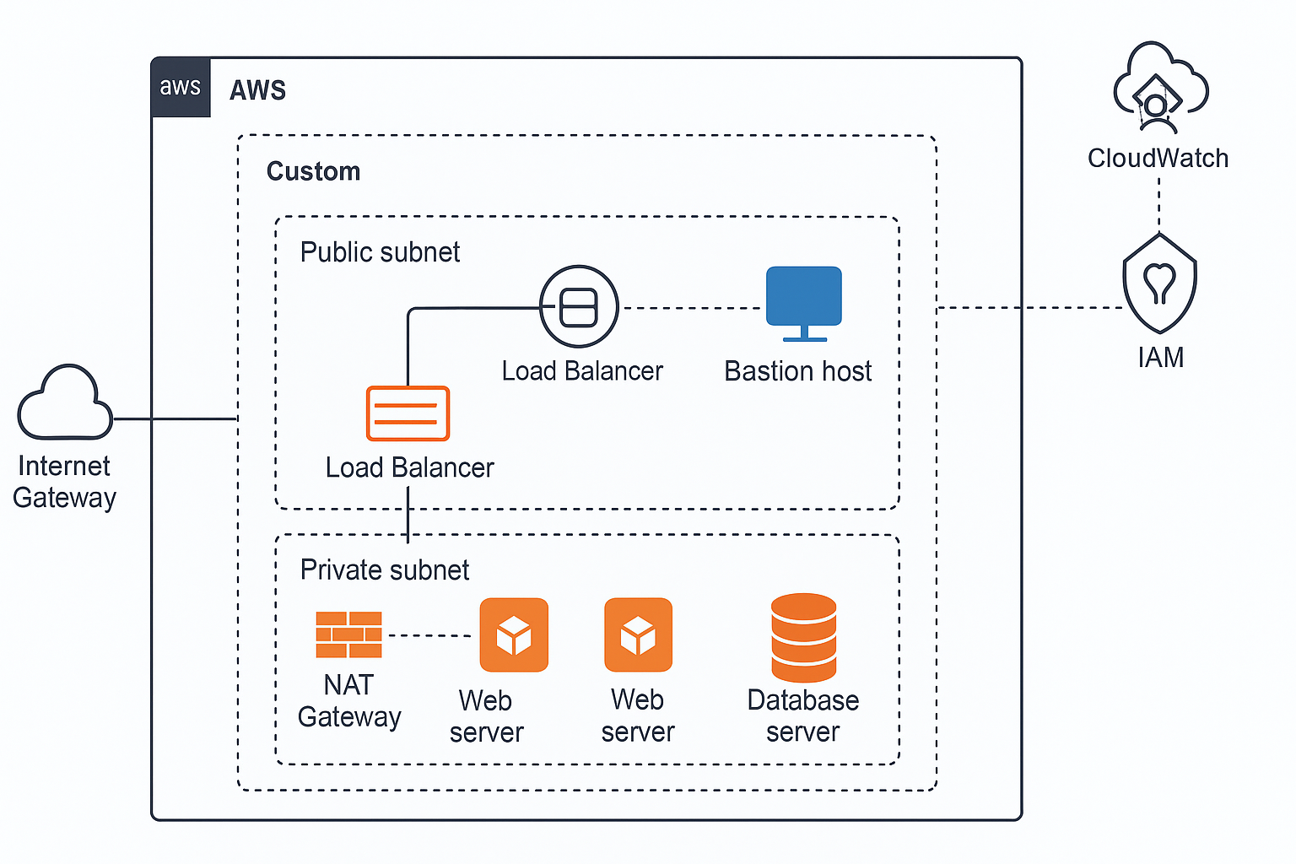

**Simplified Explanation of the AWS Architecture Diagram**

This architecture aims to safely host a web application and ensure that it can support a large number of users.

We set up two different kinds of subnets in our Virtual Private Cloud (VPC):

• Public Subnet: The internet is connected to this section. Among its components is a load balancer, which distributes incoming web traffic among several servers to prevent any one server from becoming overloaded.

• Private Subnet: The internet cannot see this section. It consists of: o Web servers that host the application but can only be accessed via the load balancer.

• A database server that houses data and is only accessible by web servers—not by internet users.

For the public subnet to send and receive internet traffic, an Internet Gateway is connected to the VPC.   
By using a NAT gateway, private servers can connect to the internet (for patches or updates) without the internet being able to access to them.  
To regulate what traffic is permitted, security groups function similarly to firewalls:   
  
The database only allows connections from the web servers on the database port; the web servers only permit web traffic (HTTP/HTTPS) and restricted SSH access.

The purpose of Identity and Access Management (IAM) is to manage who has access to AWS resources.   
CloudWatch is used for alarms, logs, and server health monitoring.   
All things considered, this configuration ensures that the web application is open to the public while maintaining the security and privacy of the database and internal servers.

# **Task 2: Implementation : Launch EC2 Web Server (in Public Subnet)**

## **Part A: VPC and Gateway**

### **Description**

This part mainly focused on configuring the core networking components of our AWS architecture. We made sure that the resources in the private subnet could safely access the internet through a NAT Gateway, while those in the public subnet could do so with the help of Internet Gateway (IGW). Isolating backend resources from direct public exposure while preserving essential outbound access (for software updates, for example) was the aim. This part set the foundation for controlled communication between application layers in the VPC..

### **Preparation**

* Created a custom VPC with separate public and private subnets.
* Attached an Internet Gateway (MyIGW) to the VPC to enable internet access for the public subnet.
* Created and associated PublicRouteTable with PublicSubnet1, adding a route (0.0.0.0/0) pointing to the IGW.
* Allocated an Elastic IP address and created a NAT Gateway inside PublicSubnet1 to support outbound access for the private subnet.
* Associated PrivateRouteTable with PrivateSubnet1, adding a route to the NAT Gateway (0.0.0.0/0).
* Verified subnet associations and routing configuration using the VPC visual map in the AWS Console.

### **Observations**

* PublicSubnet1 had a functioning route to the internet through the IGW, allowing EC2 instances to be publicly accessible.
* PrivateSubnet1 had no direct internet access, but could securely reach the internet via the NAT Gateway.
* The use of separate route tables for public and private subnets helped enforce traffic separation.
* The visual network map clearly showed how each subnet was linked to its respective routing components and gateways, confirming the architecture was logically and securely segmented.

### **Reflection**

This part helped to define our understanding of subnet-level routing and gateway usage in AWS. It was literally eye opening to see how a simple route table entry could determine whether a resource is public-facing or internally secured. Setting up the NAT Gateway was especially important for enabling safe outbound internet traffic without exposing the database server or the backend systems. The hands on setup made it easier to grasp how public and private resources can coexist securely within the same VPC and how critical routing and gateway configurations are to that design.

### **Screenshots:**

1.1 - The custom VPC (MyProjectVPC) has been successfully created which Confirms the base networking environment has been defined

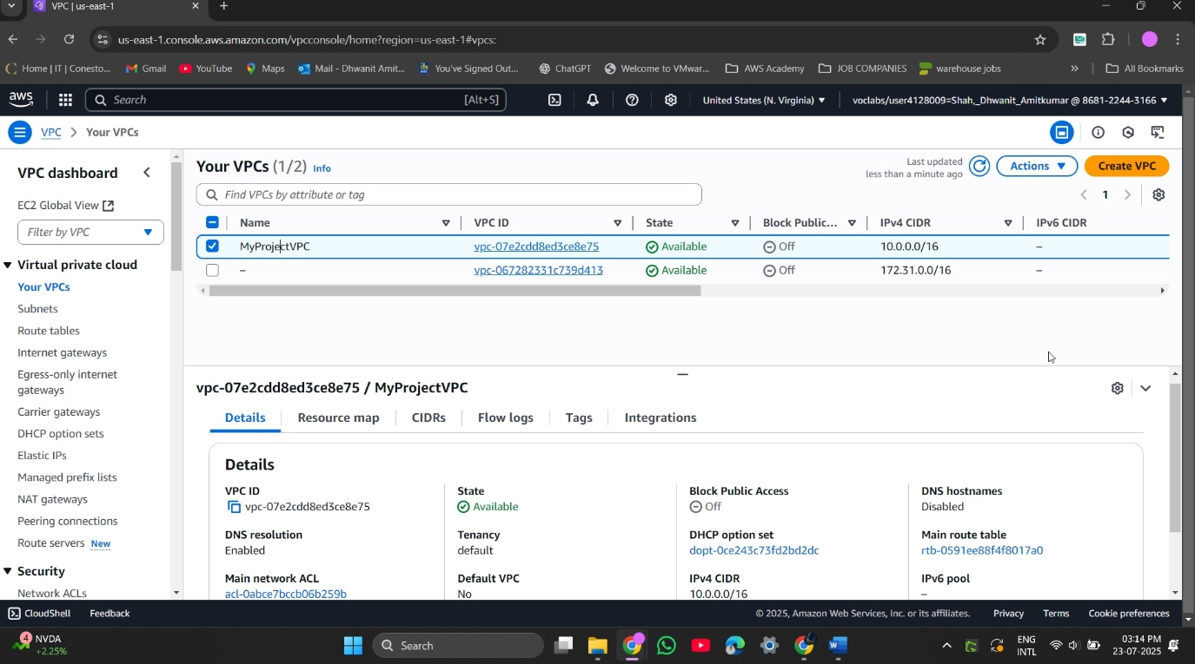

1.2 - PublicSubnet1 and PrivateSubnet1 both created which Confirms segmentation of public and private network zones

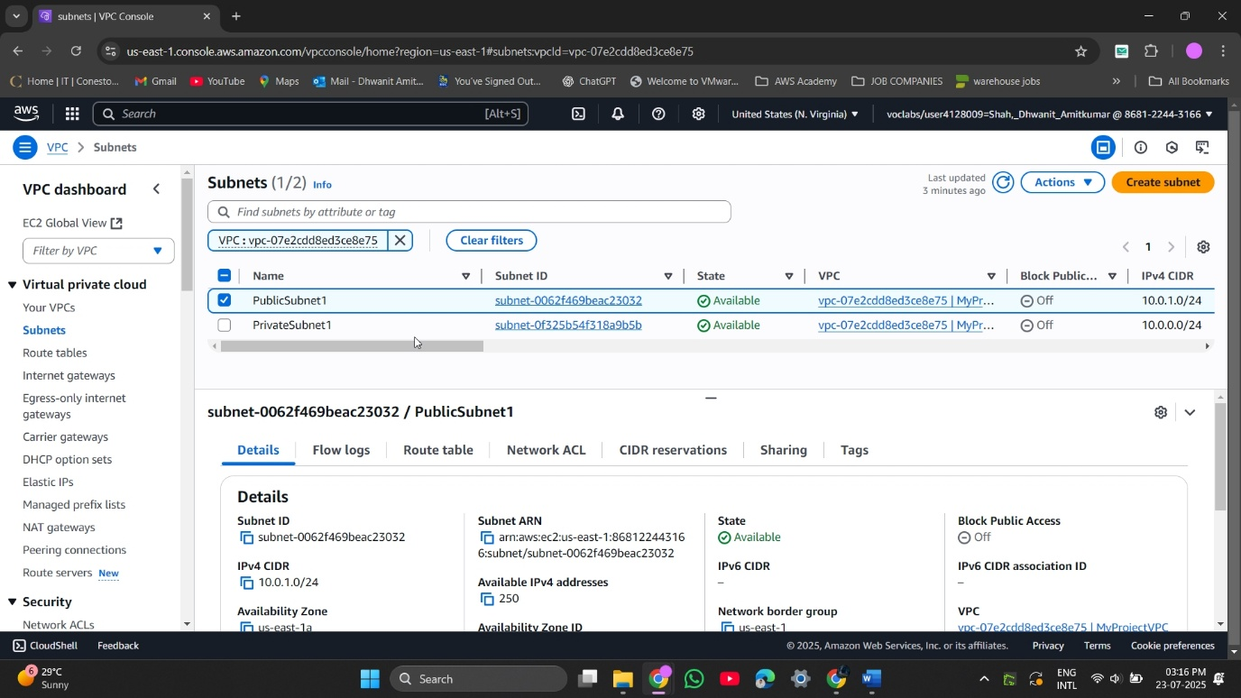

1.3 - The Internet Gateway (MyIGW) attached to the custom VPC which Required for external access from public subnet

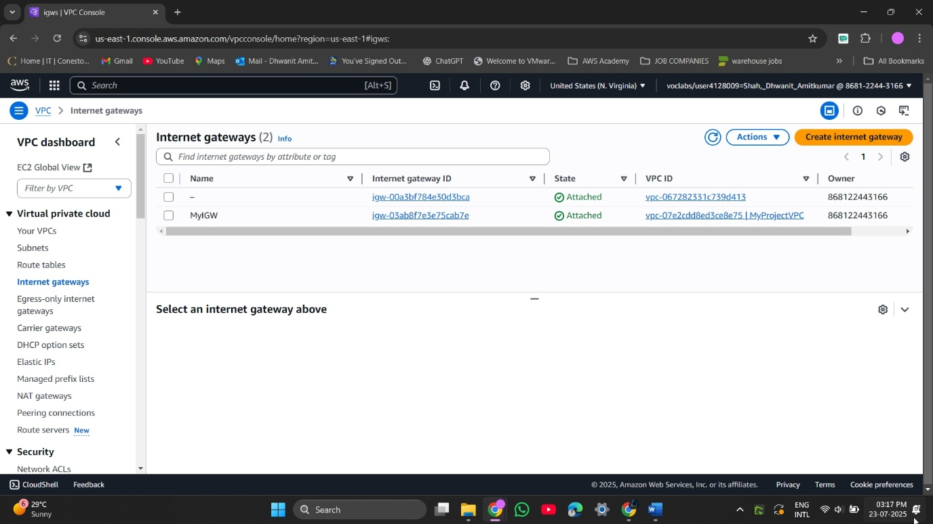

1.4 - Route table for public subnet contains route to internet (via IGW) which Ensures that instances in PublicSubnet1 can access the internet

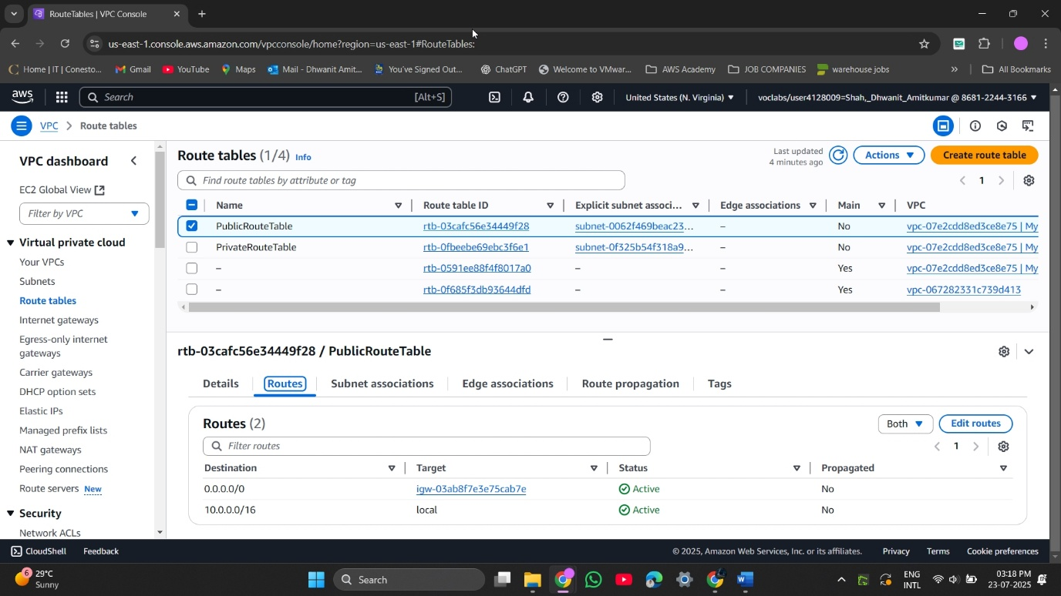

1.5 - PublicRouteTable is associated with PublicSubnet1 which Links the route rules with the correct subnet

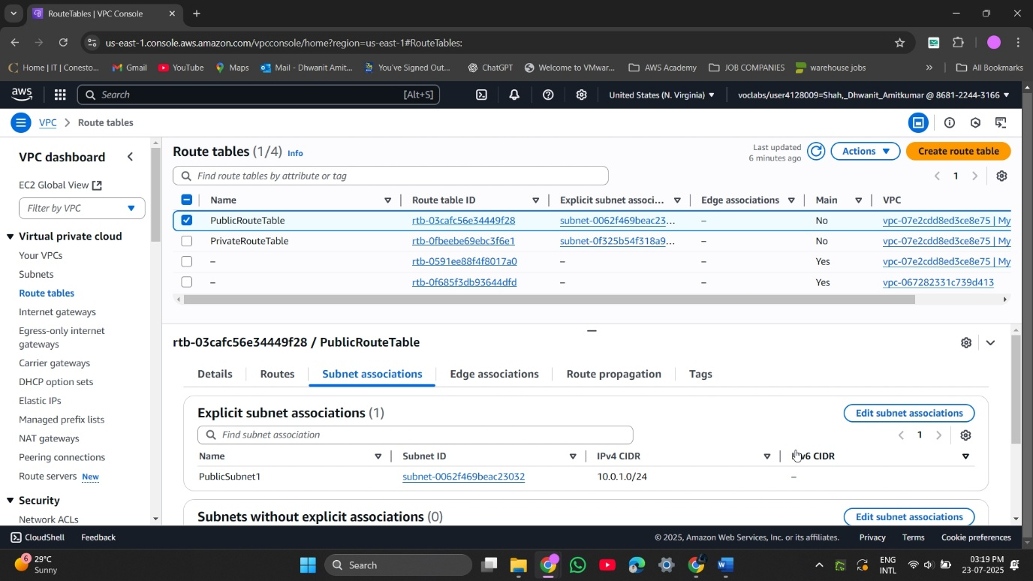

1.6 - PrivateRouteTable is associated with PrivateSubnet1 which Ensures isolated routing for the database or backend

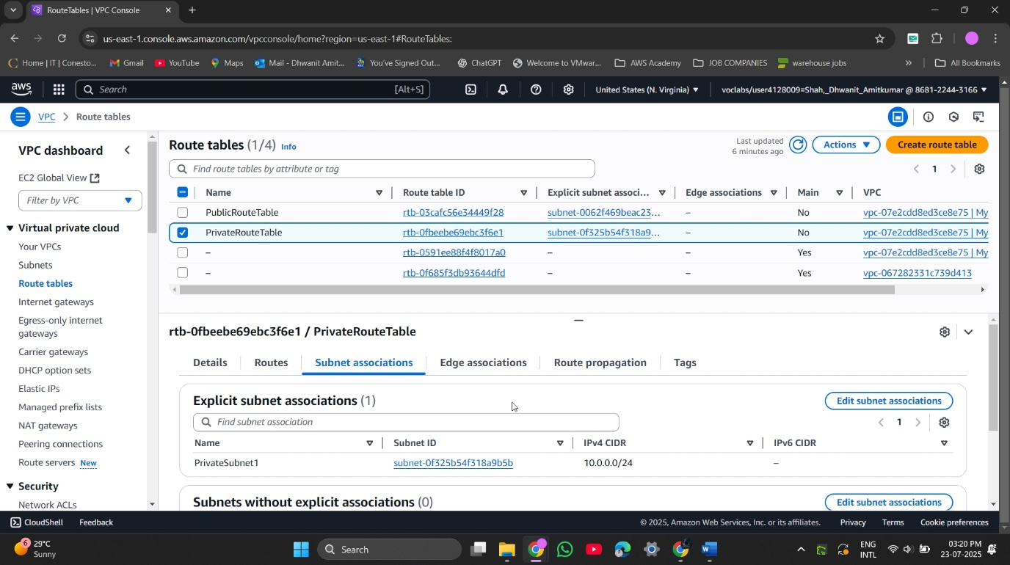

1.7 - NAT Gateway is created in PublicSubnet1 using the allocated Elastic IP which Enables internet access for private subnet EC2 instances (like DB server)

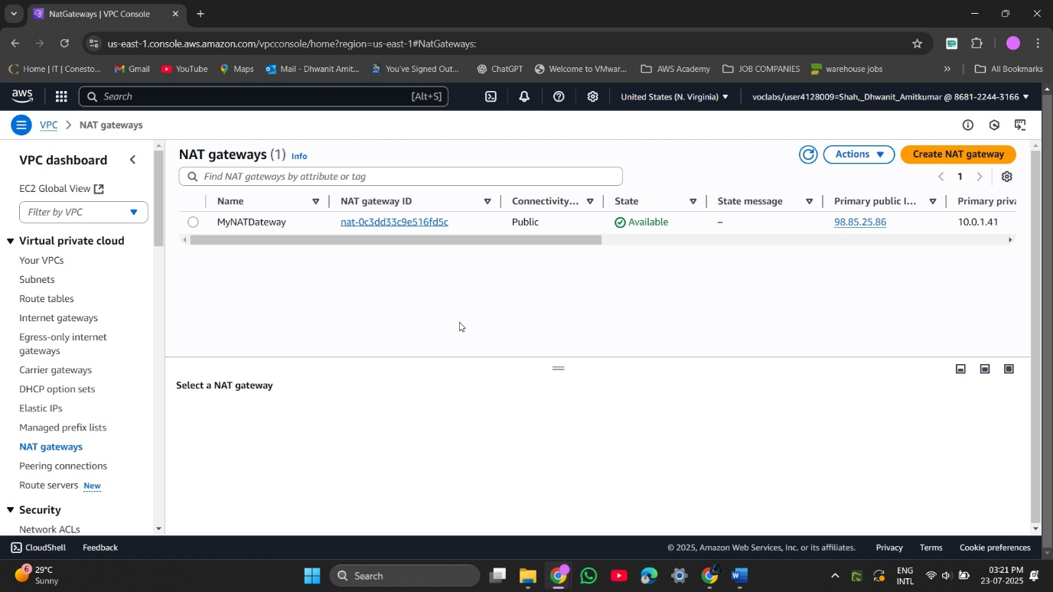

1.8 - Route in PrivateRouteTable directs outbound internet to NAT Gateway which Private subnet can now reach internet securely (no direct exposure)

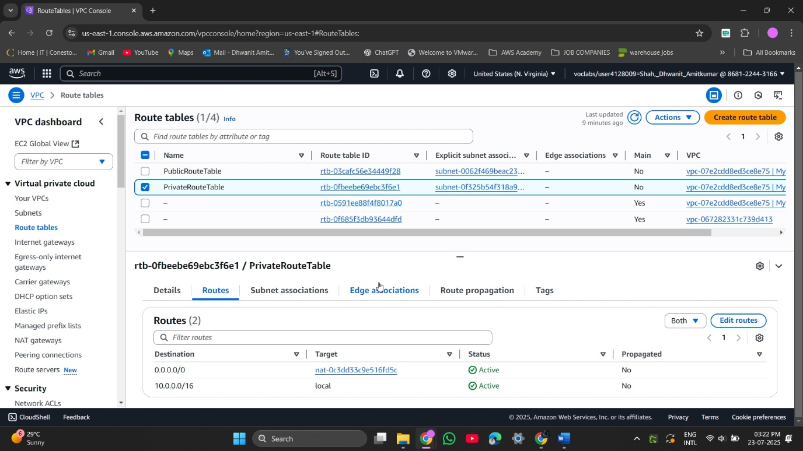

1.9 - Visual resource map of your VPC and its components (subnets, IGW, NAT) which can be Useful visual summary of your architecture

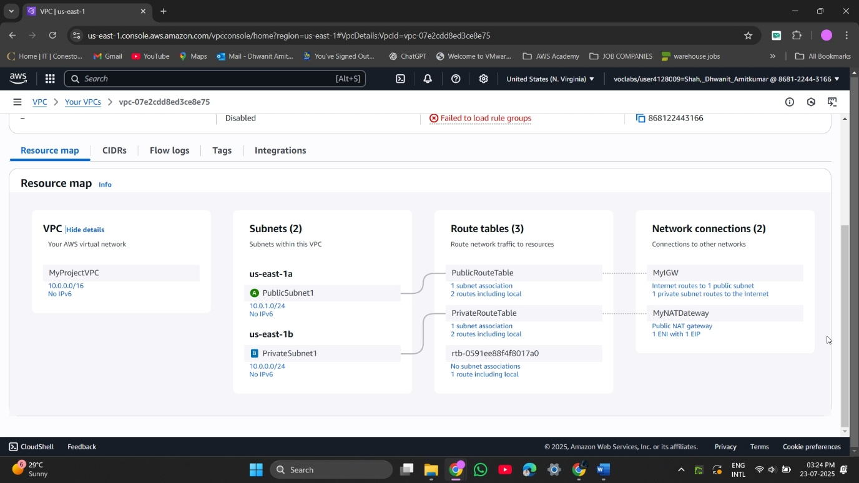

## **Part B: Launch EC2 Web Server (in Public Subnet)**

### **Description**

In this part B, we first installed Apache, then set up a security group to permit SSH and HTTP, launched an Amazon Linux 2 web server in the public subnet, and made sure the server could be easily accessed by a browser.

### **Preparation**

* Selected Amazon Linux 2 AMI and t2.micro instance type.
* Chose PublicSubnet1 in our custom VPC.
* Enabled Auto-assign Public IP for internet access.
* Created a new key pair for SSH access.
* Created a Security Group (WebSG) allowing:
  + SSH (port 22) from anywhere (admin access)
  + HTTP (port 80) for web traffic
* Launched the instance and connected via SSH.
* Installed Apache using sudo yum install httpd -y.
* Verified the web server via public IP in a browser.

### **Observations**

* EC2 instance received a public IP and was running in us-east-1 availability zone.
* Apache installation completed without errors.
* A simple HTML page was served successfully when accessing the instance’s public IP.

### **Reflection**

This task showed the full process of launching a public-facing EC2 instance. Setting up security groups and Apache felt straightforward, and seeing the live webpage really brought the infrastructure to life. It was also a good hands-on test of using public IPs, security groups, and web server setup in AWS

### **Screenshots:**

2.1 -Accessing EC2 Dashboard and Selecting ‘Launch Instance

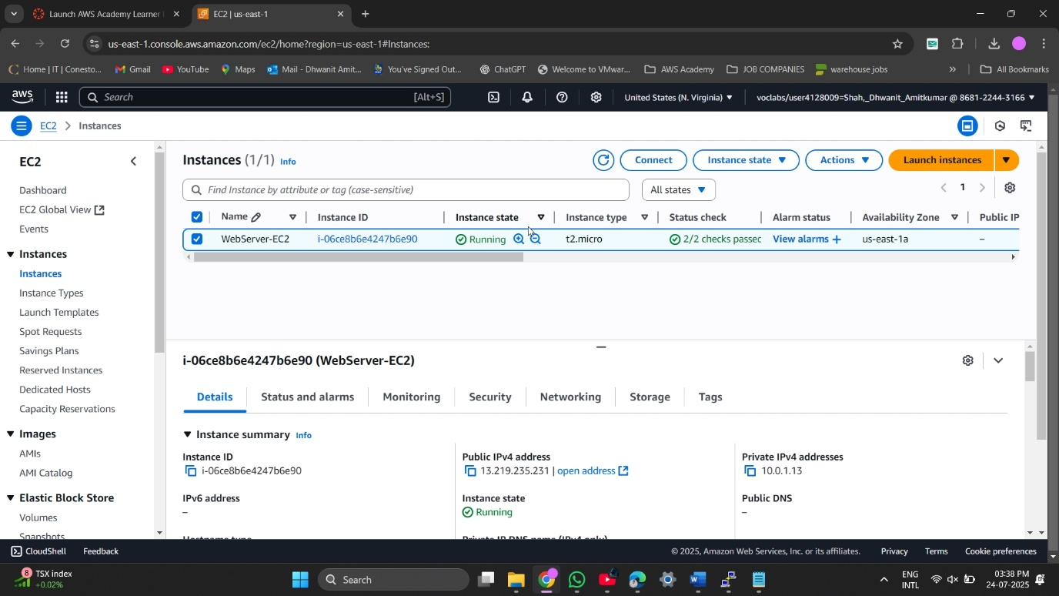

2.2 - Creating New key for SSH Access

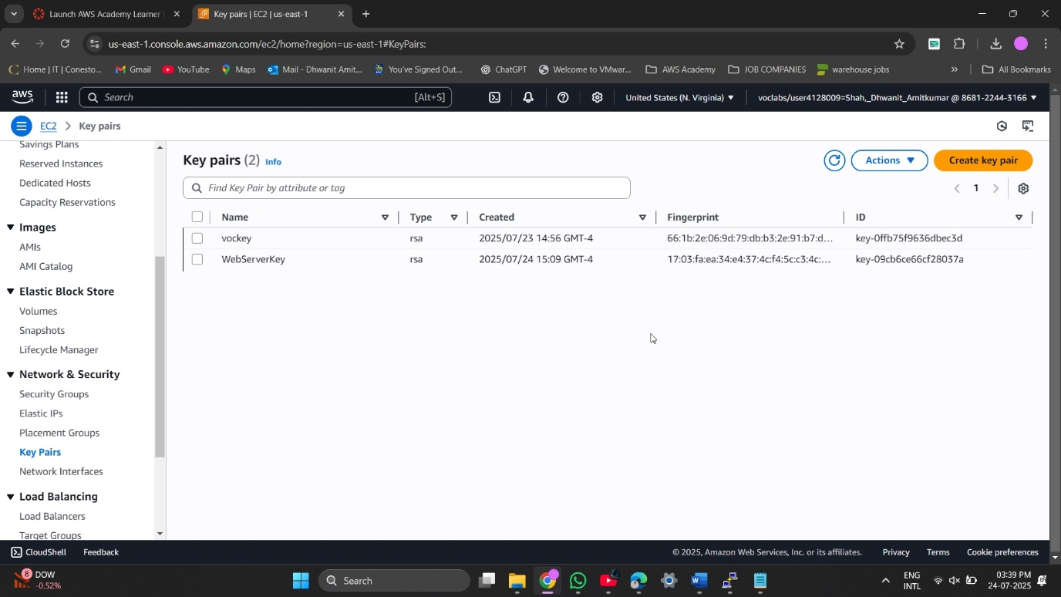

2.3 - Configuring Network VPC Public Subnet & Enabling Auto-Assign Public IP

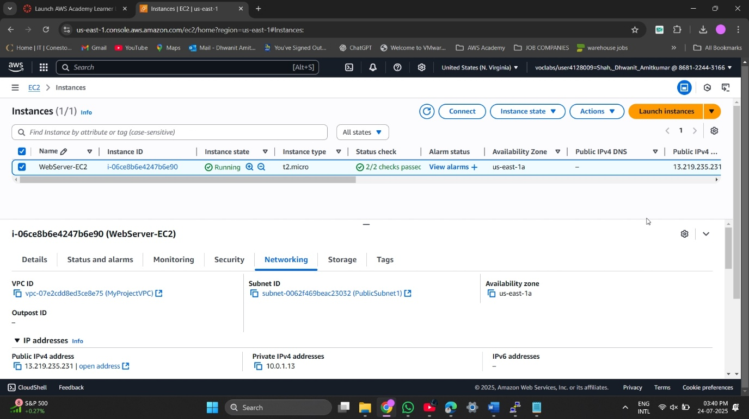

2.4 - Creating New Security Group Allowing SSH (Port 22) and HTTP (Port 80) Access

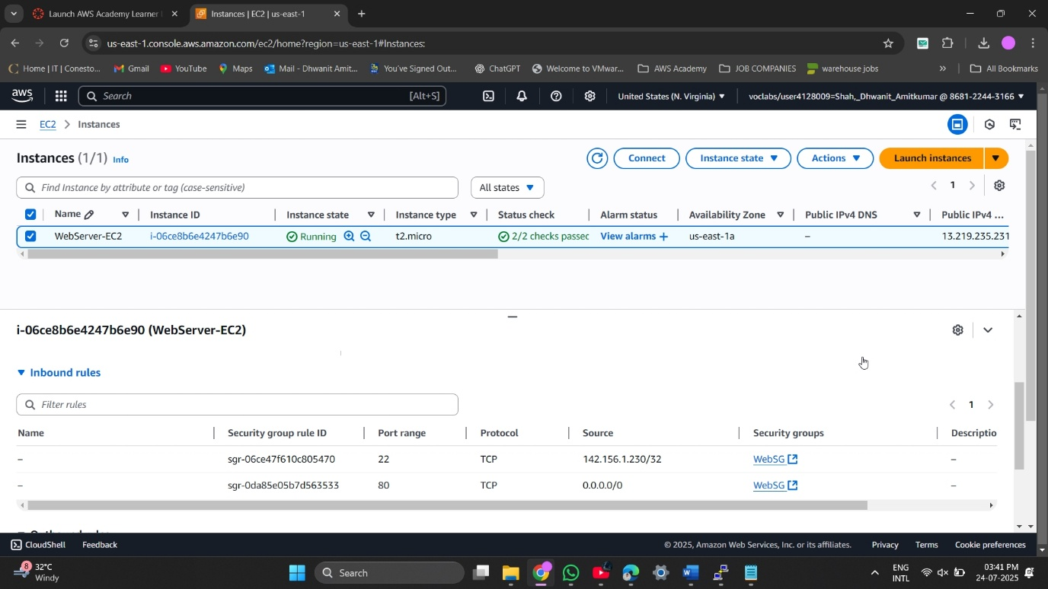

2.5 - Verifying 8 GB Default EBS Storage for EC2 Instance

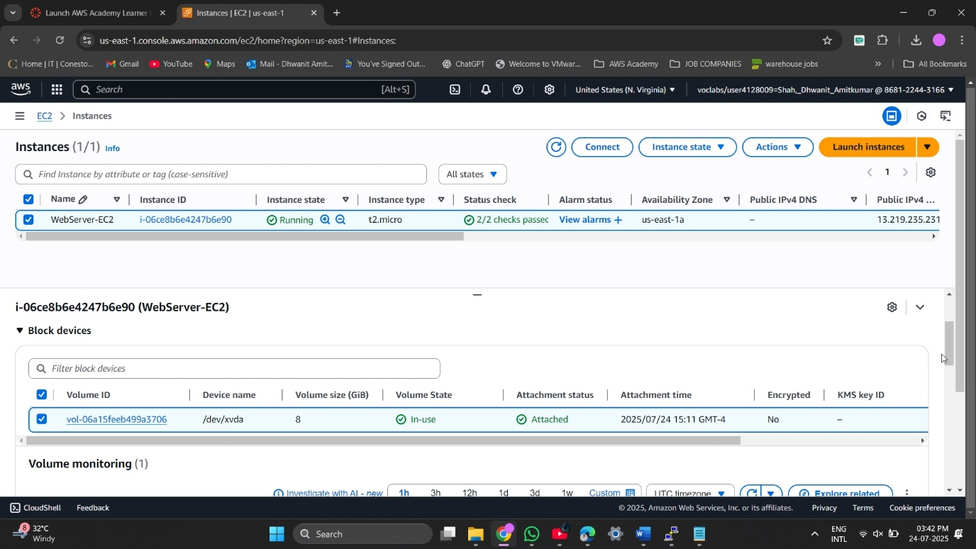

2.6 - connected to amazon linux machine

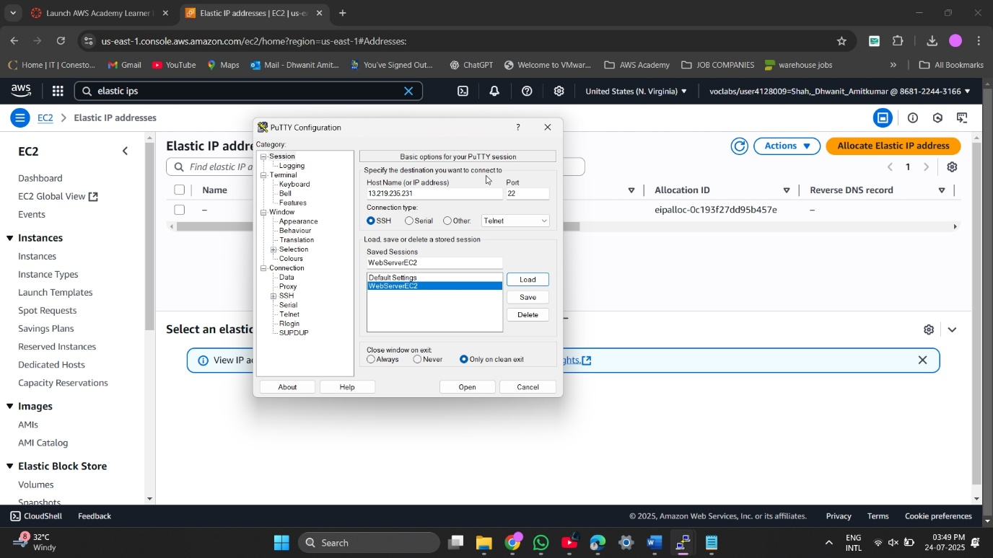

2.7 - installed apache server on amazon linux machine

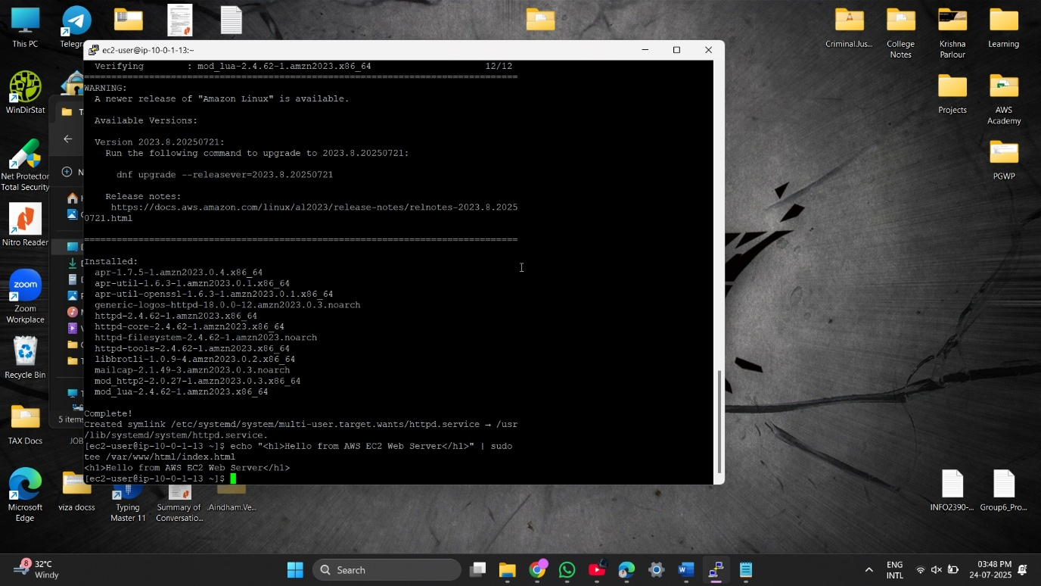

## **Part C: Launch EC2 DB Server (in Private Subnet)**

### **Description**

Here, we launched a database server inside the private subnet with no public IP and secured it by allowing MySQL access only from the web server’s security group. Connectivity was verified through internal communication.

### **Preparation**

* Launched a new EC2 instance (Amazon Linux 2, t2.micro) in PrivateSubnet1.
* Assigned an existing private key for SSH (used for testing from web server).
* Chose no public IP to ensure it’s not accessible from the internet.
* Created and applied a DB Security Group (DBSG):
  + Inbound:
    - Port 3306 (MySQL) from WebSG
    - SSH and ICMP for internal testing (optional)
  + Outbound: All traffic allowed (needed for updates via NAT)
* Verified private IP assignment.
* Tested connectivity from web server to DB server using ping.

### **Observations**

* DB server correctly launched in private subnet and had no public IP.
* Security Group allowed only web server communication.
* Ping from web server to DB server succeeded, proving VPC-level connectivity.
* NAT Gateway allowed outbound traffic from DB instance (tested via yum update).

### **Reflection**

Launching the DB server in a private subnet reinforced the importance of security best practices. It was satisfying to isolate the DB layer while still allowing internal app communication. Testing connectivity and setting precise security group rules gave a deeper understanding of how AWS handles internal traffic versus public exposure.

### **Screenshots:**

3.1 - Naming the DB Server and Selecting Amazon Linux 2 AMI

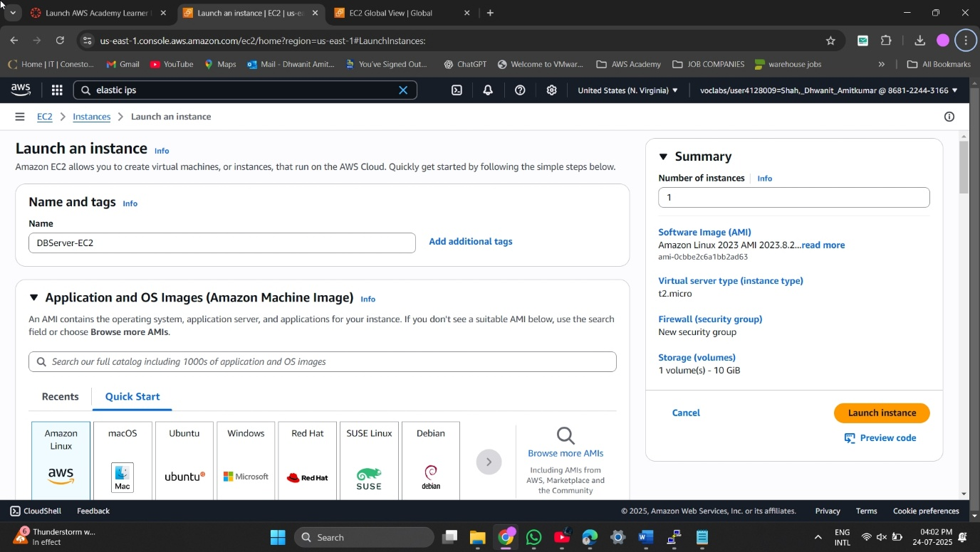

3.2 - Choosing t2.micro Instance Type for DB Server

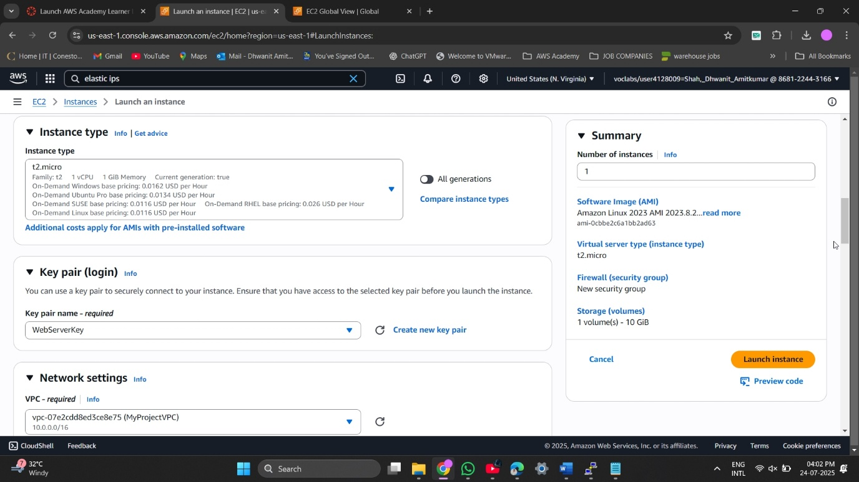

3.3 - Assigning to Existing VPC and Private Subnet

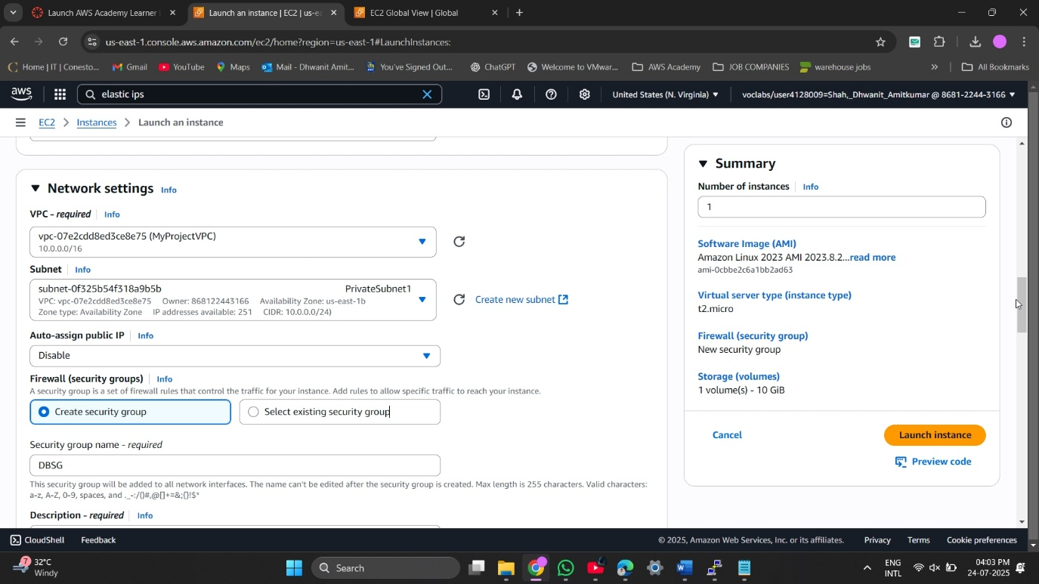

3.4 - Selecting Existing DB Key Pair for SSH Access

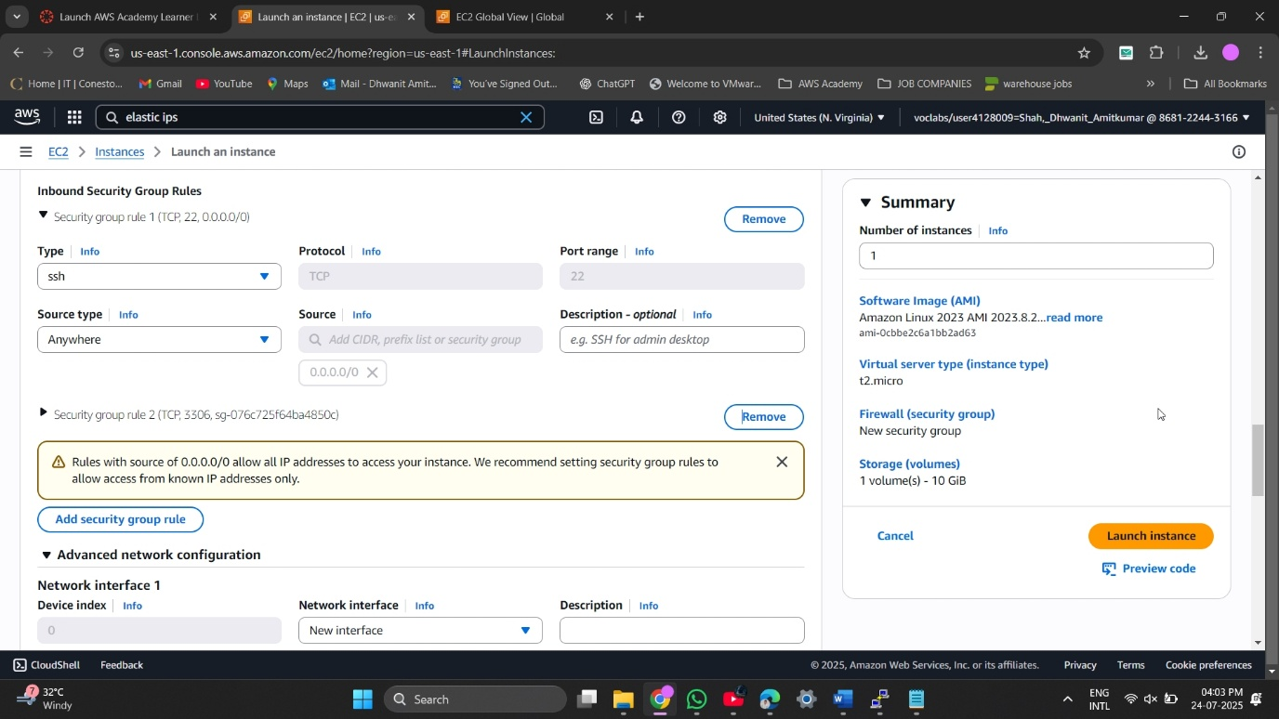

3.5 - Assigning DB Security Group Allowing MySQL Port 3306

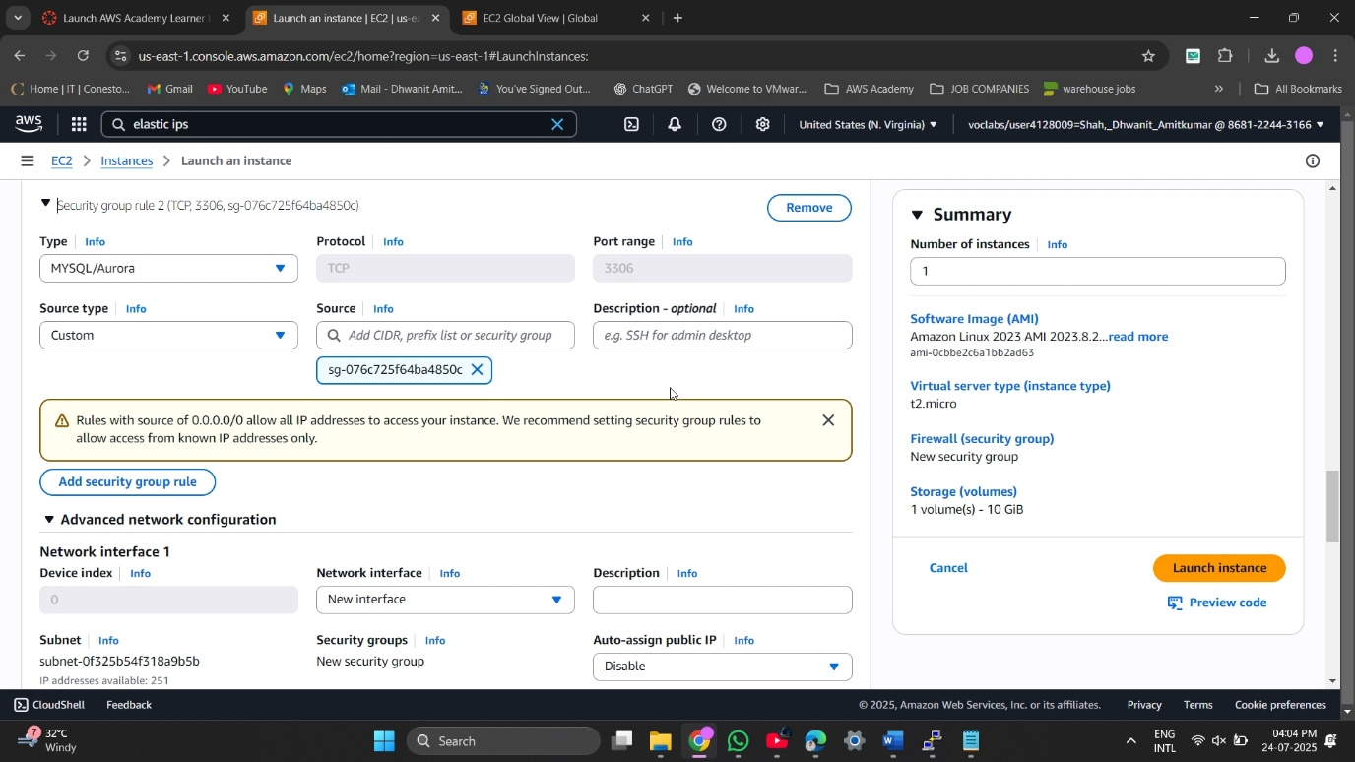

3.6 - Storage Settings for DB Server EC2 (10 GB EBS)

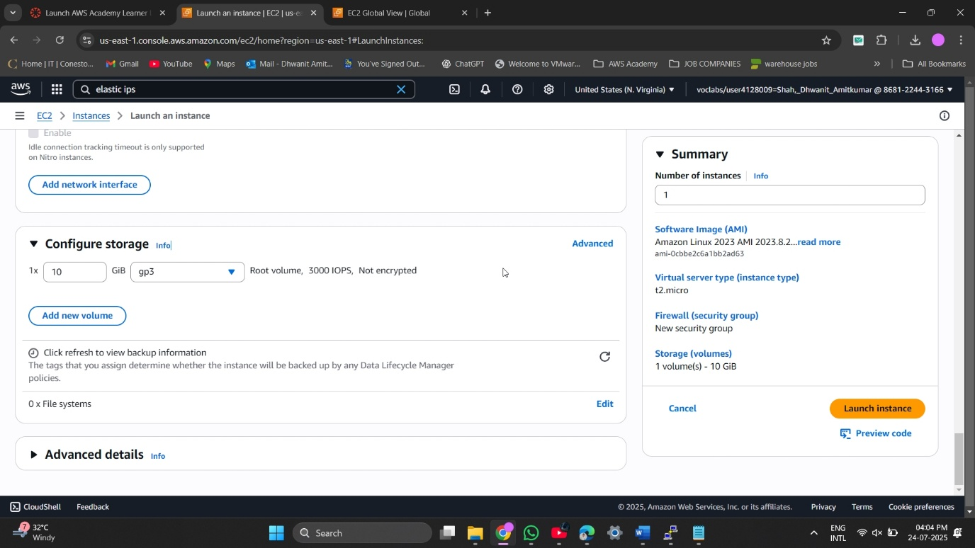

3.7 - Database Server Instance Details (Private IP + Subnet Info)

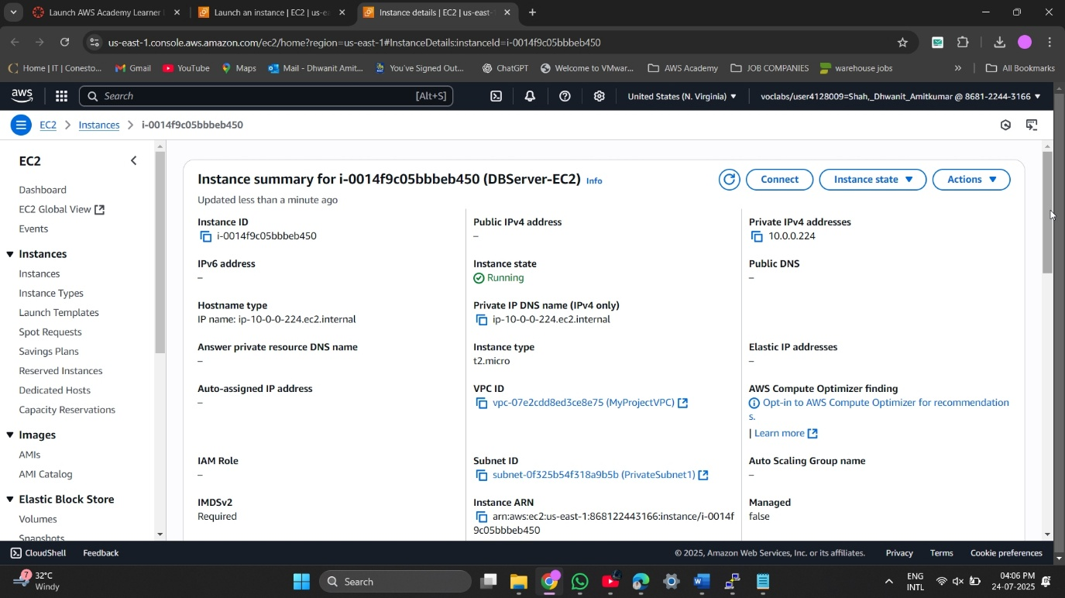

3.8 - Verifying Connectivity Between Web Server and DB Server (Ping Test)

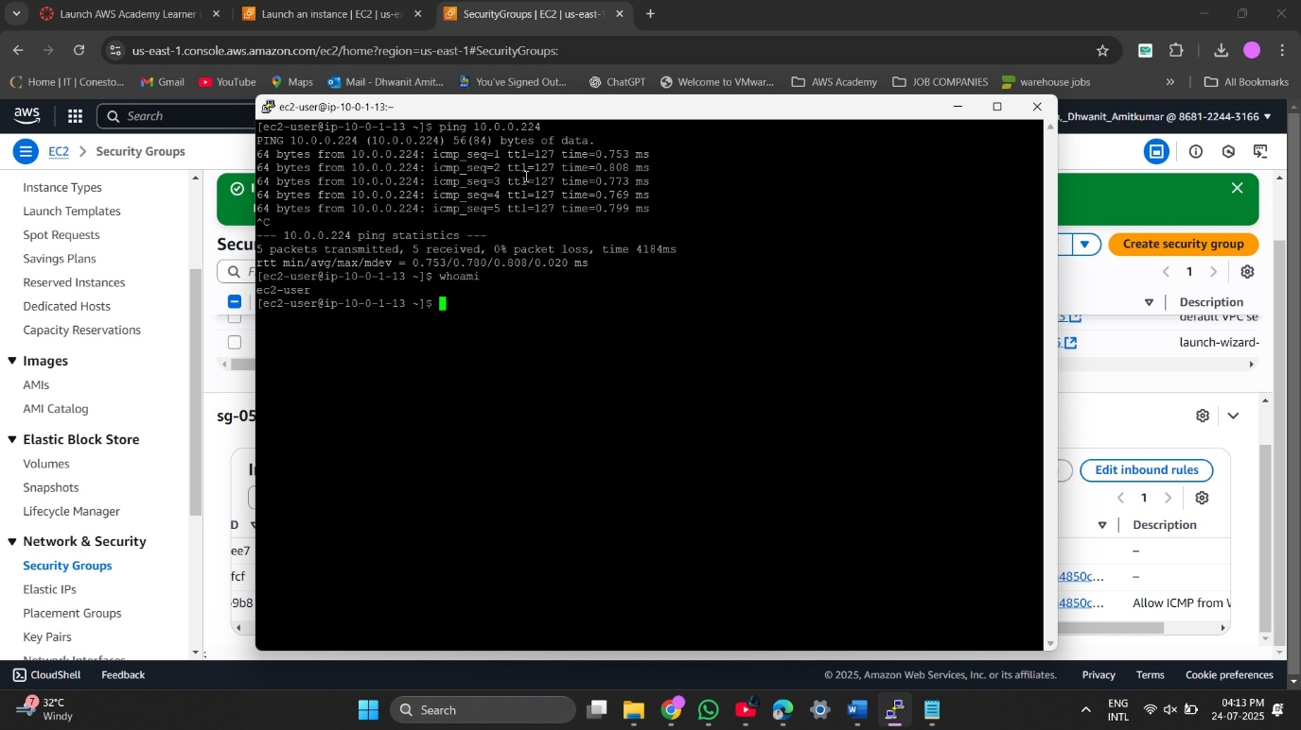

3.9 - Demo web page for ec2 public server

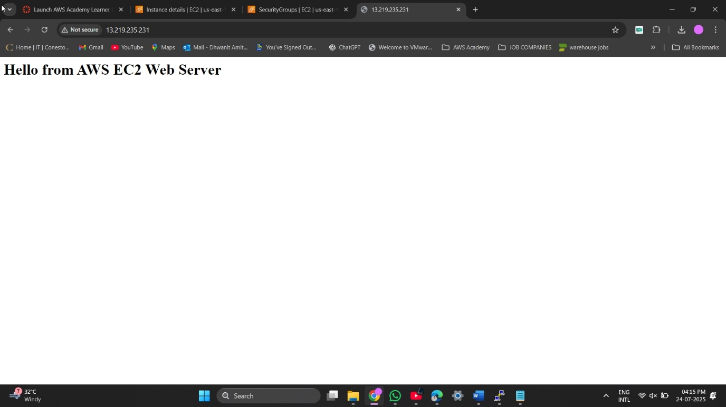

# **Task 3: Terraform & automation**

### **Description**

In this task, we moved away the entire infrastructure setup using Terraform rather than just clicking through the AWS Console by hand. This involved setting up the route tables, establishing the security groups, deploying the EC2 instances, building the VPC, and establishing public and private subnets. Beside this, we made sure that everything was repeatable, version-controlled, and consistent across environments by writing the infrastructure as code.

### **Preparation**

* Created and structured the following Terraform files:
  + main.tf for core resources like VPC, subnets, EC2, route tables, and security groups.
  + variables.tf to declare configurable values such as region, instance type, CIDR blocks, etc.
  + outputs.tf to print useful information like EC2 public IP addresses.
  + provider.tf to define the AWS provider and region.
* Used user_data in the EC2 web server configuration to automatically install and start Apache, along with a basic HTML message.

### **Observations**

* Ran terraform init to successfully initialize the project and install the AWS provider plugin.
* terraform plan accurately showed what resources would be created, which helped prevent misconfigurations.
* After terraform apply, the infrastructure was launched successfully with no manual steps.
* The EC2 web server booted up and automatically served the message:  
   *“Hello from AWS EC2 Web Server”* via Apache.
* Public IP of the EC2 instance was correctly displayed as part of the Terraform output.

### **Reflection**

This task was a major milestone in the project. It showed the real power of Infrastructure as Code (IaC) using Terraform. It saved a lot of manual effort and removed the risk of missing steps during the setup. While small syntax issues and dependency ordering caused some minor delay during the first few tries, but resolving them was a great learning experience. Automating the infrastructure gave us confidence that we could scale or replicate this setup easily in the coming future.

### **Screenshots:**

1.1 - Terraform Project Files Structure & AWS Provider & declared all configurable inputs

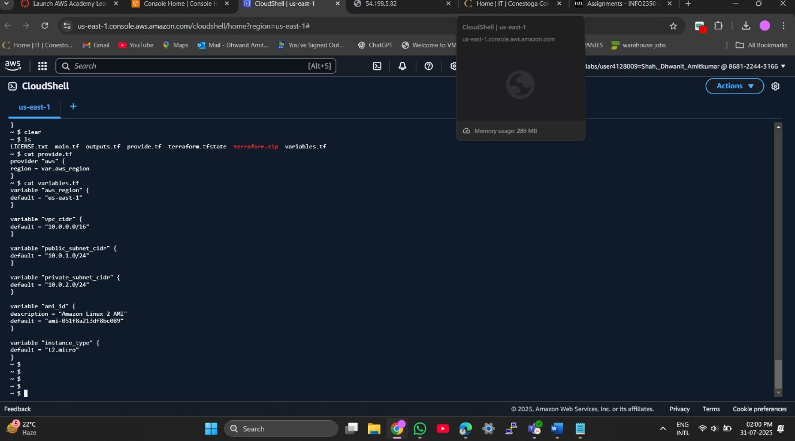

1.2 - Core infrastructure definitions (VPC, Subnets, EC2, Security Groups)

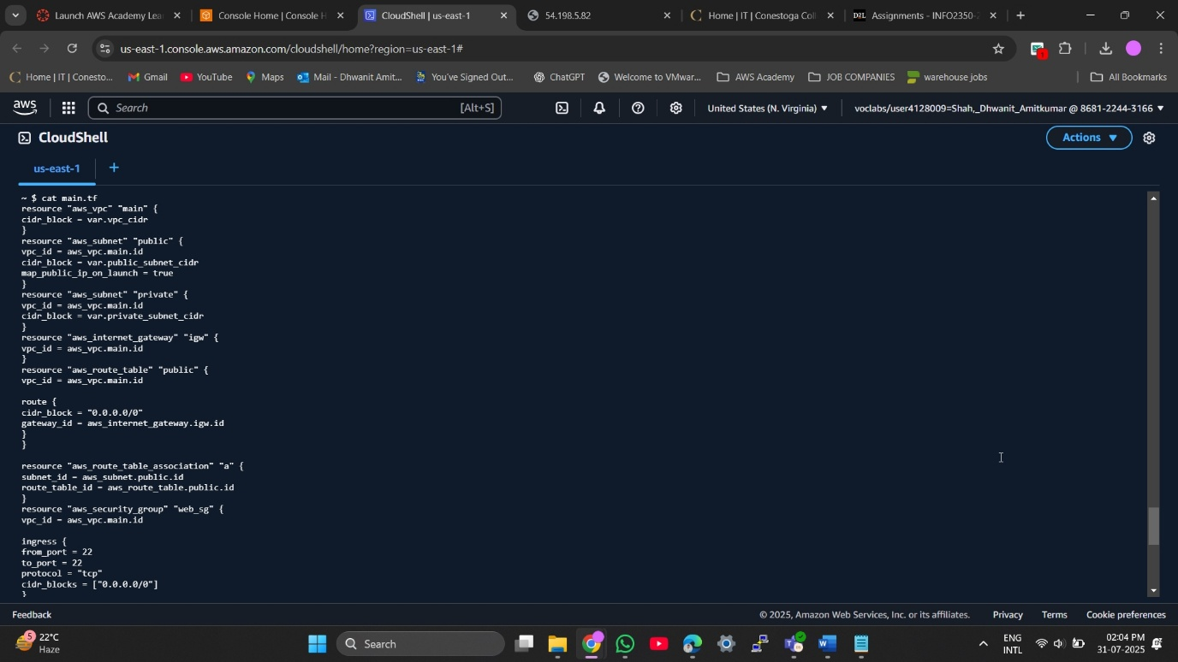

1.3 - Defines outputs like instance IP addresses

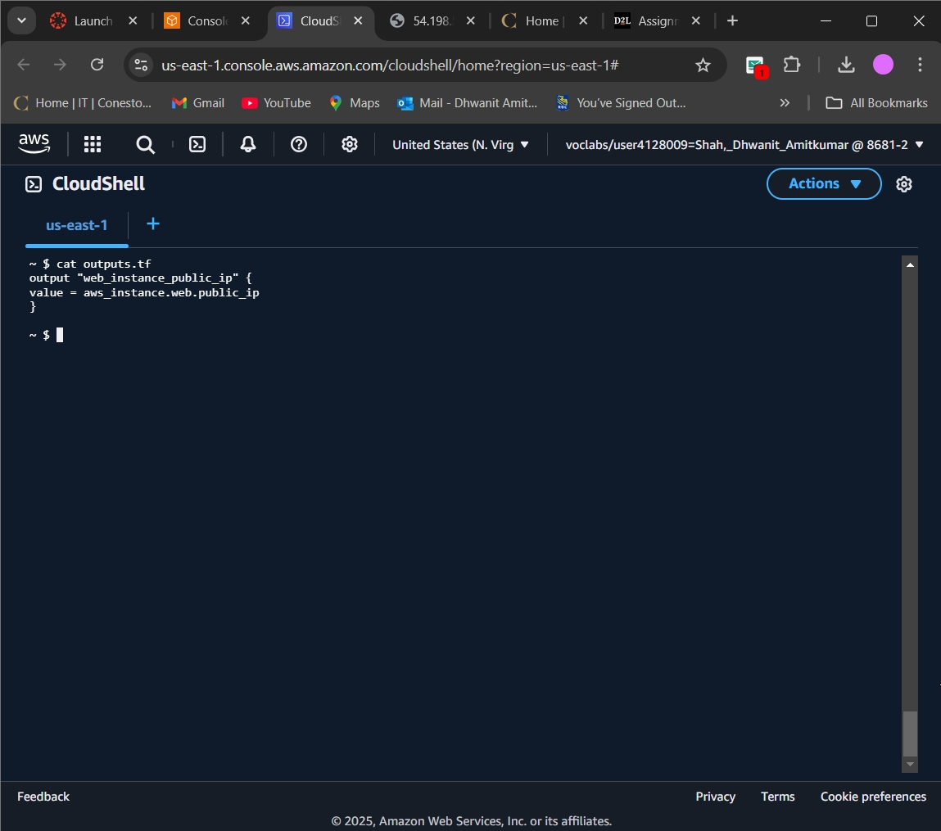

1.4 - terraform init — Initializes Terraform working directory

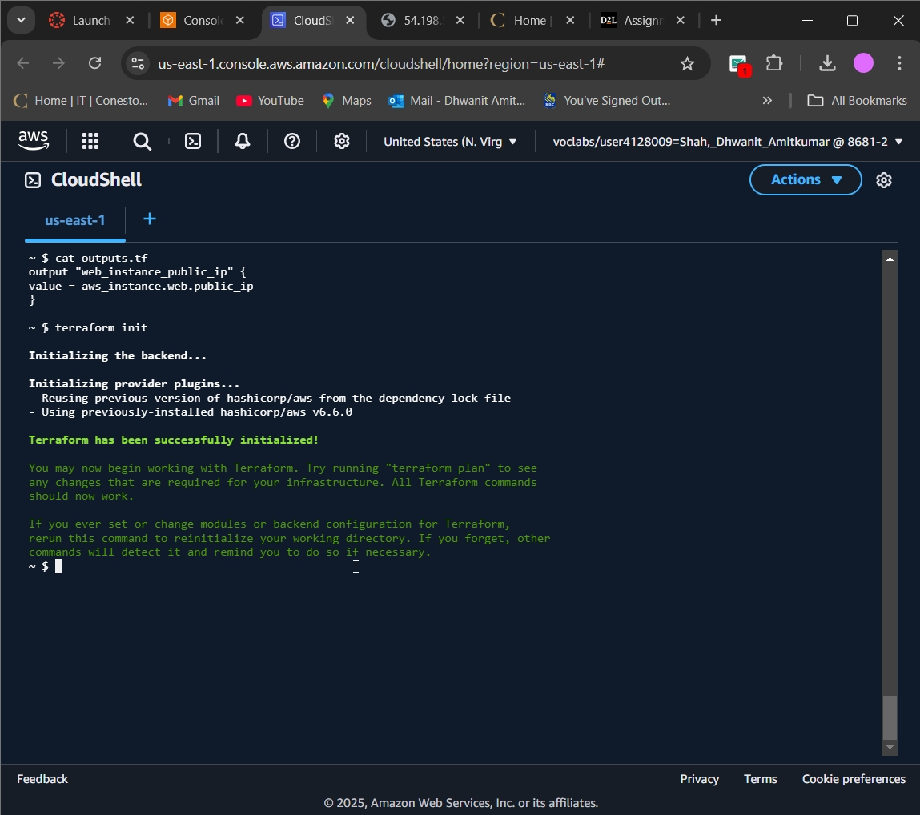

1.5 - terraform plan — Shows infrastructure to be created

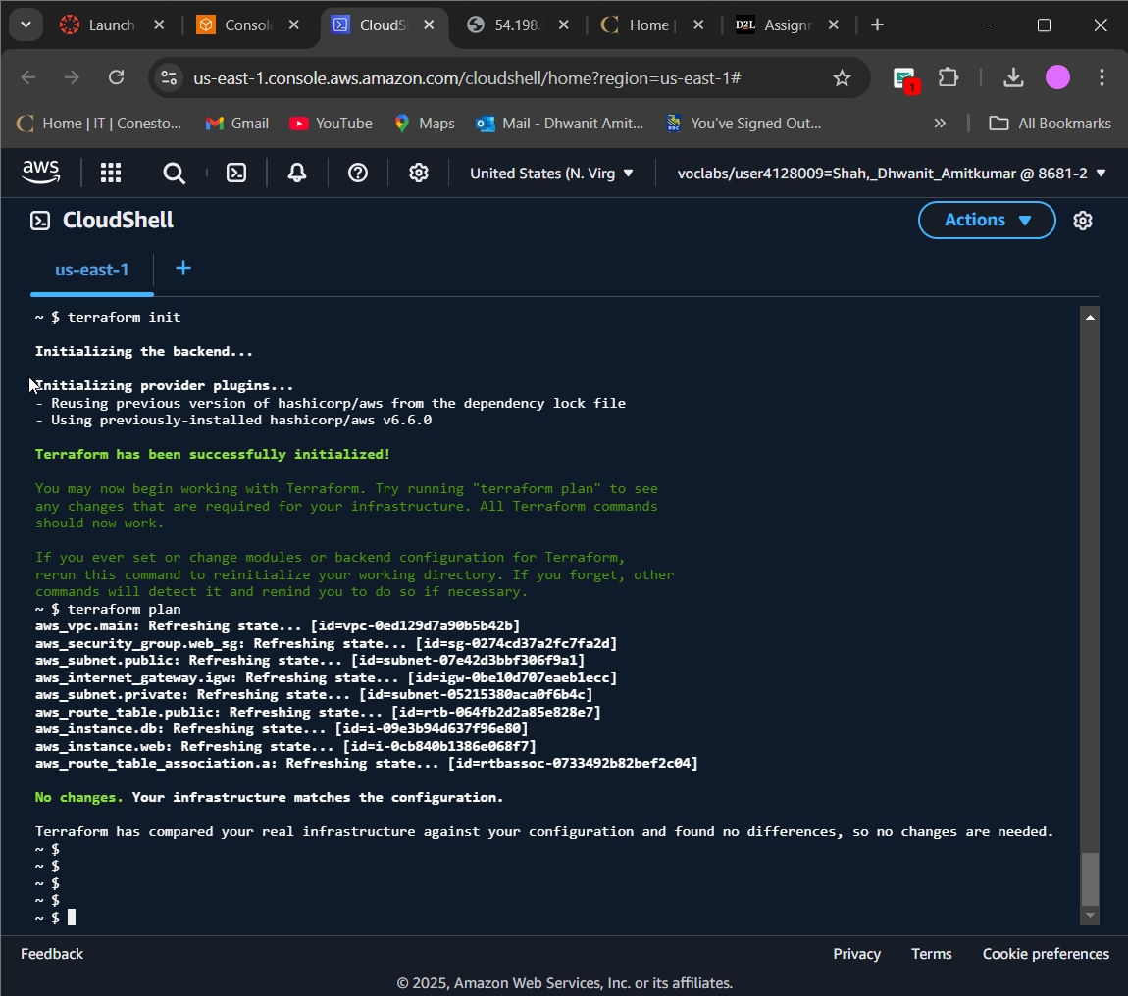

1.6 - terraform apply — User confirmation before applying changes

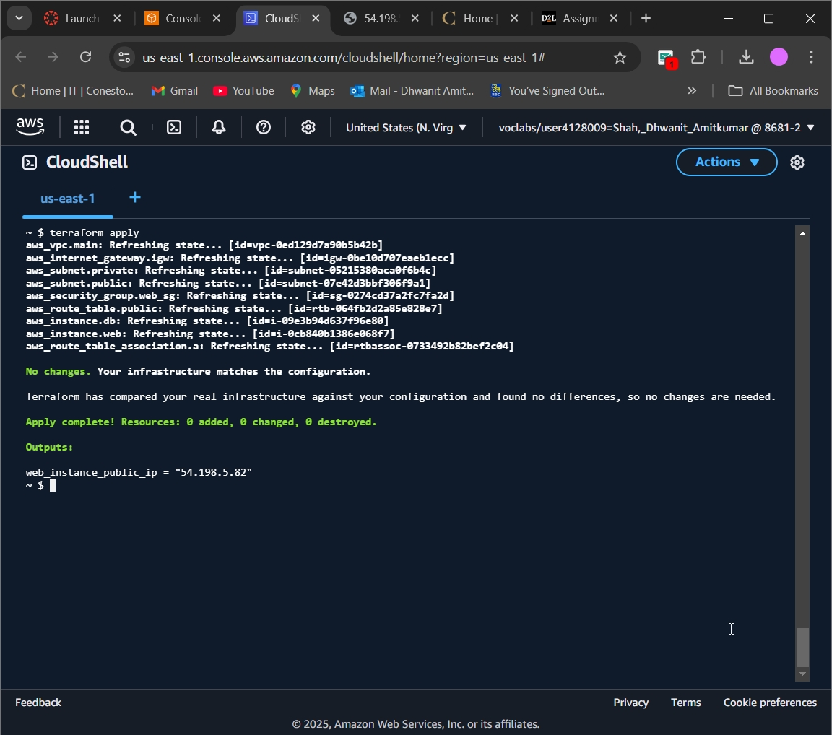

1.7 - Web Server Response — “Hello from AWS EC2 Web Server”

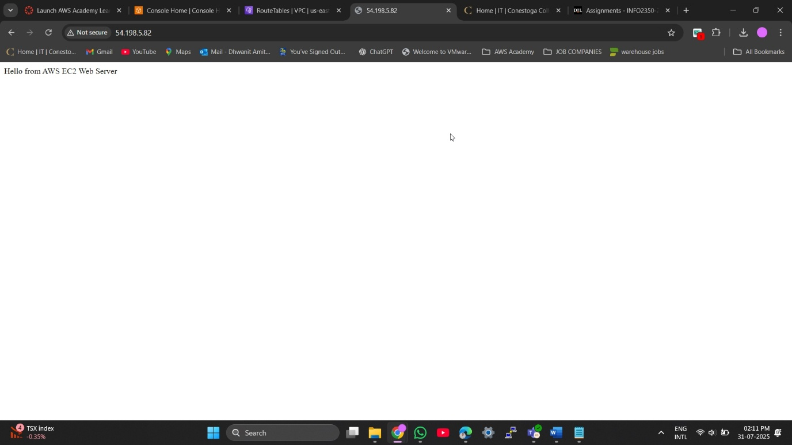

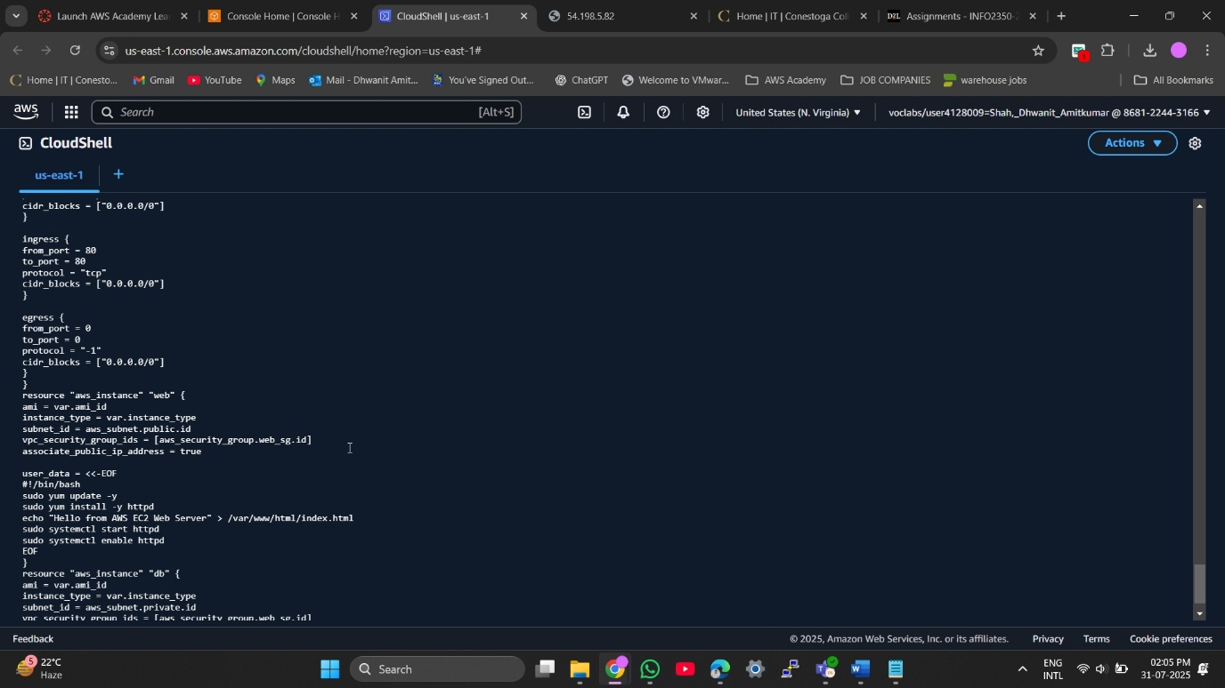

# **Task 4: Security Considerations**

For this project, our goal wasn’t just to get a web app running we also put a strong focus on making it secure. While we were working in the cloud, especially with the public-facing applications, security becomes a big deal. Our servers are connected to the internet, that’s why we needed to make sure only the right people and services can talk with each other.

A big part of our setup was that letting users could access the web app from anywhere online, without exposing the backend database. Thats meant keeping everything properly separated and protected within our VPC.

We ran into three key security concerns, and here’s how we solved them:

**1. Keeping the Database Server Hidden**

Since the database might hold sensitive information, we didn’t want it exposed to the internet at all. So, we placed it in a private subnet inside our custom VPC this basically means the server has no public IP and can’t talk directly to the internet.

We also created a security group just for the database. Think of it like a firewall rule. It only allows connections from the web server’s security group, and only on port 3306, which is the default for MySQL.

So with this setup:

* The database is not reachable from the internet.
* Only the web server can talk to it.
* Even if someone somehow knew its internal IP, they couldn’t connect unless they were part of the allowed group.

**2. Making the Web Server Public — But Not Too Open**

The web server needed to be reachable by users, so that we can place it in a public subnet and gave it a public IP. But we didn’t wanted to open the floodgates to everything.

We added a security group for the web server that allowed:

* Port 80 (HTTP) so users can access the site through any browser.
* Port 22 (SSH) only for admin use, and even this can be restricted to the specific IPs for extra safety.

Everything else is blocked.

This setup allows us to:

* Let users visit the site normally.
* Connect to the server when needed for updates or maintenance.
* Keep things tight by avoiding open ports that aren’t necessary.

**3. Giving the Database Internet Access Without Exposing It**

Although the database shouldn't be visible online, it still needs internet access sometimes — like for downloading software updates.

To solve this, we used a NAT Gateway. This allows resources in a private subnets in order to reach the internet, but doesn’t allow anything from the internet that to reach them.

We placed the NAT Gateway in a public subnet and updated our route tables so that the traffic from the private subnet routes through the NAT. That way:

* The database can safely access the internet (for updates).
* It stays completely hidden from the outside world.
* We don’t need to open up unsafe access just to keep it updated.

Other Security Practices We Followed

Aside from the main setup, we also followed some other good habits:

* Used separate route tables for public/private subnets to better control network traffic.
* Avoided default VPCs and default security groups — everything was created with intention and customized for our setup.
* Followed the principle of least privilege — meaning we only gave the minimum permissions necessary for everything to function.
* Didn’t hard-code any sensitive data. Instead, we let AWS handle internal communication securely using security groups.

**Final Thoughts**

By taking these extra steps, we didn’t just build a working AWS environment we built one that’s secure, scalable, and follows real-world best practices.

Our web app is accessible to users on the internet, but the database stays completely safe inside a locked-down private zone. Updates happen securely, and all traffic is filtered and controlled.

This project gave us hands-on experience with tools like VPCs, subnets, security groups, and NAT Gateways and most importantly, showed us how to design cloud systems that are actually safe in practice, not just in theory.

### **Screenshots:**

4.1 - Private Subnet Associated with Route Table (No IGW Access)

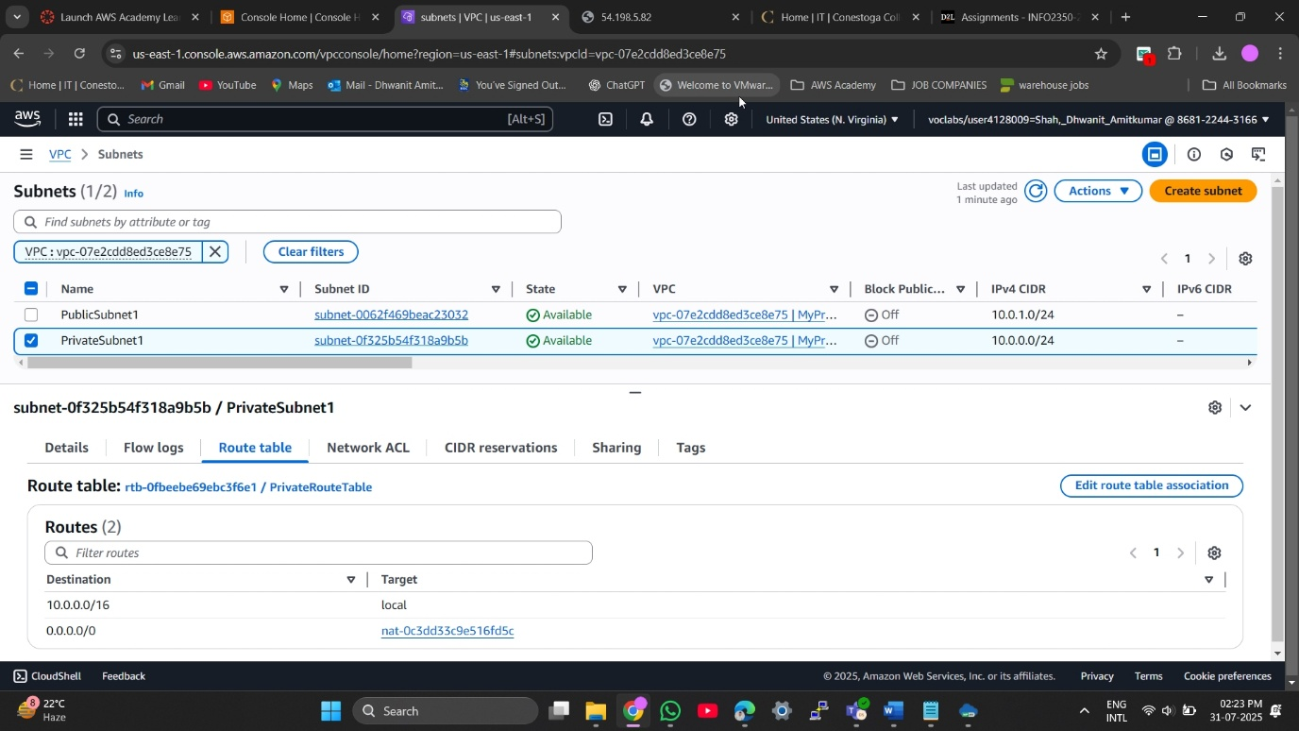

4.2 - Database Security Group Inbound Rules (Restricted to Web SG on Port 3306)

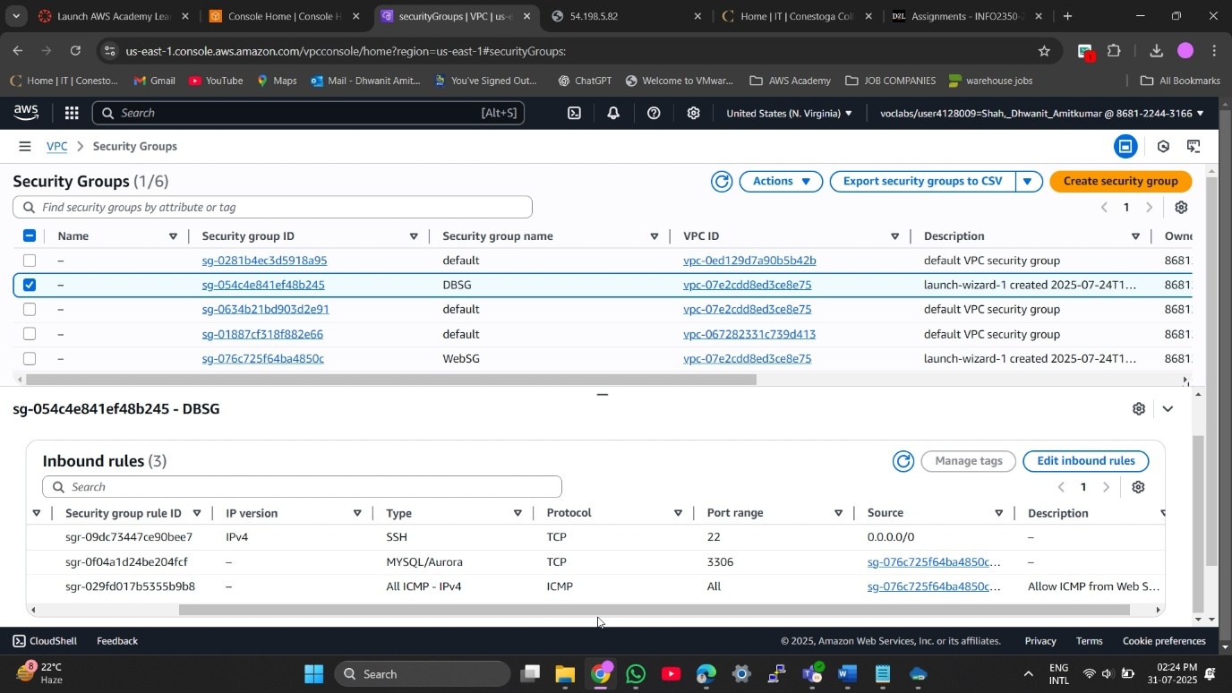

4.3 - Database Security Group Outbound Rules (All Traffic for Software Updates)

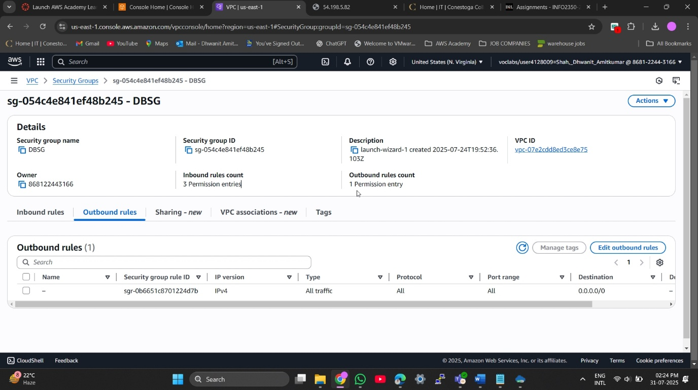

4.4 - No Public IP Assigned to Database Instance in Private Subnet

